Functionality in Workday to Stop or Prevent a Student’s Registration

By Kristina Kelpe – Created 1.28.25

- Holds – This prevents all registration from happening. A student cannot add, drop, or withdraw from courses.
- Date Controls – You can use the date controls to prevent registration. This image displays how they work.
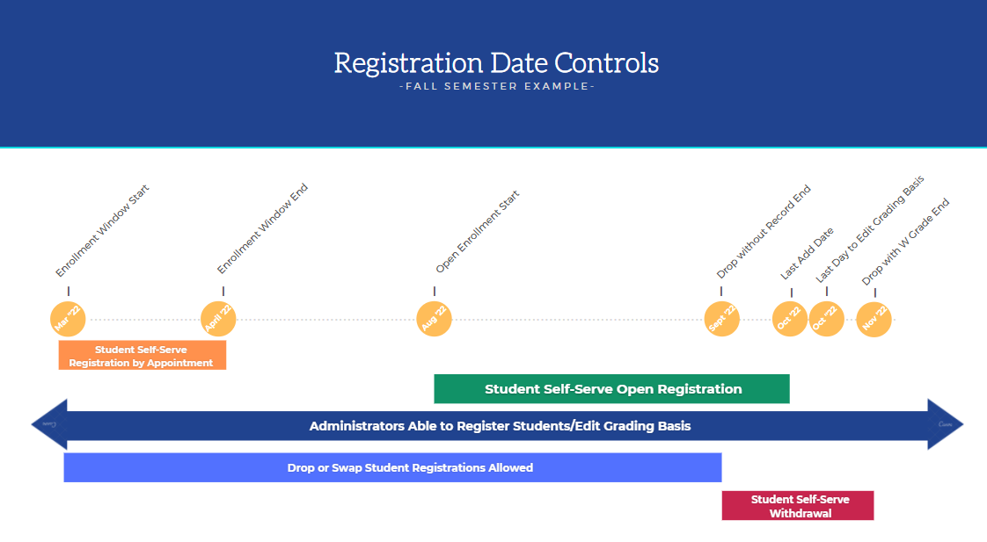
- Enrollment Access & Grading Policy – This policy in Workday determines who can have access to courses. Think of it like a broad pre-requisite. It saves you the time from having to put an individual prerequisite on a course (e.g. Must be a Graduate Level student to register in a graduate level course). This policy also determines what grading basis and grading schemes students can get access to by default and by request.
- Prerequisites – You can set a prerequisite on a course section. A student must meet this requirement in order to be able to register. Or they can use the task “Request Course Section Prerequisite Override” and it will kick off a business process (BP) that will go to the instructor asking permission for the student to registers
- Registration Appointment - If the time is before Open Enrollment, the student must have a Registration Appointment.

